Nalpeiron Licensing Service

Using License Manager

Thank you for buying our Software. We protect our Software from pirates using an easy to use Copy Protection System. This guide will explain how to ‘activate’ your software when you receive it along with how to easily move, remove and license our software.

Contents
Using License Manager 1
Using the Trusted Activation Service 1
Description OF the License Manager utility 2
Activate using the Internet 3
Activate using the “self serve” activation process 6
Manual Licensing using email/phone 14
Move A License from Computer to Computer 16
Moving your license using the Internet (De-Activation) 20
Remove a License with Proof that It was removed 21

Using the Trusted Activation Service

Nalpeiron makes Consumer friendly technology designed to prevent you from suffering from unscrupulous or other untrustworthy people on the Internet. Everywhere you see the Trusted Activation logo you can be assured of a safe, easy and secure Software Activation process.

- TRUSTED: We will ensure your trust is not "abused" when Activating your Software with a Trusted Activation site.
- NO SPYING: We do not need to collect any personal information from you. Activation is 100% anonymous. You choose to supply any of your personal details only when you "register" on the system.
- SAFE AND SECURE: The service is safe and secure, using 128 bit encryption to protect your information both during Activation and on the Activation Site.
- NO NASTY SURPRISES: We will not load any nasty surprises like "root kits" on your computer, we only use software made to industry standards.
- EASY TO USE: Friendly and easy to use technology that does not force you to contact your Software vendor due to endless re-activation problems.
- NO SPYWARE: We will ensure that no Spyware or viruses are ever installed on your computer during Activation with a Trusted Activation site.
- NO HASSLE TO MOVE LICENSES: We will ensure it is really easy, as simple as one-click, to move your license between existing PCs or to a new one.
- RELIABLE: Our systems and technology have been designed to work 24x7x365. Your Software will keep working even when you do a Windows re-format, partition or have to change PC parts* - no need to call your vendor!
- PREVENT PIRACY: Using Activation technology helps stamp out the Piracy epidemic and ensures you or your employer are safe from expensive fines and even up to 10 year's imprisonment.

For more details visit: http://www.trustedactivation.com

Description of the License Manager utility
This suite of utilities allows you to manage licenses installed on your PC. When installed you will have a suite of Utilities as below:

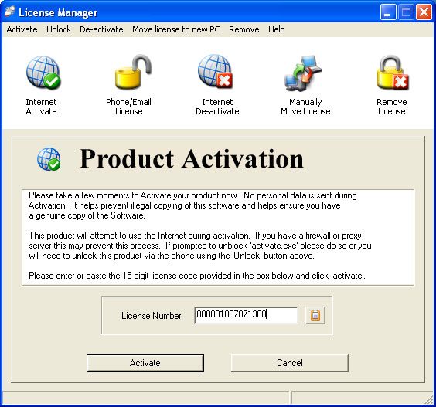

The License Manager utility allows you to control your license using both offline and activation methods.

With this utility you can:
- Check the status of a license
- Activate via the Internet, via two methods to suit your setup.
- Call or E-mail your license to get an Unlocking Code.
- De-Activate and Re-Activate your PC via the Internet when moving PCs.
- Manually move licenses to a new computer using removable storage such as floppies, USB Flash/Zip Drives, Mapped Network Drives etc
- Produce an Installation ID that will be used by your supplier to allow for the changing and/or updating of the license parameters on the local PC
- Permanently remove a license and prove it

To use this utility go to Windows START button and navigate to the software vendors program folder, then click on the License Manager Utility. It will open a dialog box as above.

You can activate your license a number of ways.

- Fully automated
- End user self serve
- Manual Licensing using email/phone

Activate using the Internet
This is a process where you simply use the License Manager application through the internet with no need to use another process. You enter a license code and click.

License Manager will open a dialog for the you allowing you to make several choices of how to Activate and License the software.

In order to activate a product the License Manager dialog is displayed and you simply copy & paste a license code into the box provided.

Then you Click ‘Activate’.

Paste button

Once the License code has been accepted, the product should now be successfully activated.

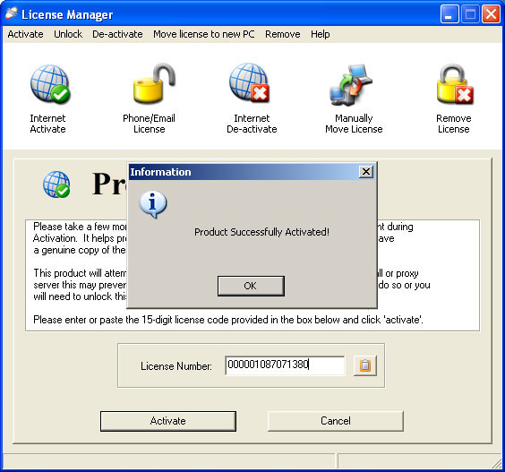

Activate via the Internet using a Proxy Server:

If you use a proxy server to access the Internet you can set these parameters in License Manager to allow you Activate.

To do this, click on the ‘Help’ text on the toolbar and choose “Advanced” from the drop down menu (as below)

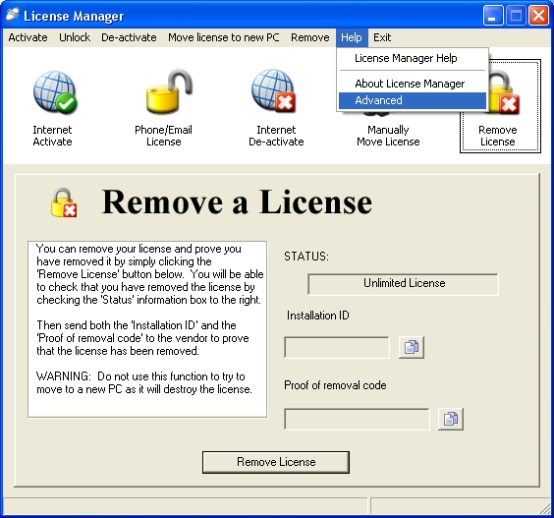

You will then need your proxy server settings and input these into the Dialog boxes provided. In order to use this option please click the “use a proxy server” radio button and then complete the details in the two dialog boxes below from your proxy server settings. You may need to contact your IT Dept. for these.

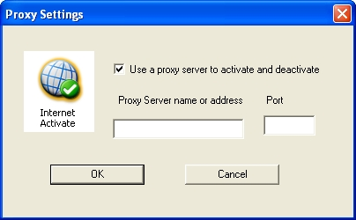

Activate using the “self serve” activation process
If you don’t have immediate access to the Internet due to firewall/proxy issues then you can visit the Self Service Portal site without being at the PC requiring licensing.

You can access this at any time from www.trustedactivation.com

You need to note the License code sent with your order along with the Installation ID shown in the License Manager (see below).

To get the Installation ID you need to click the “Phone/Email License” button.

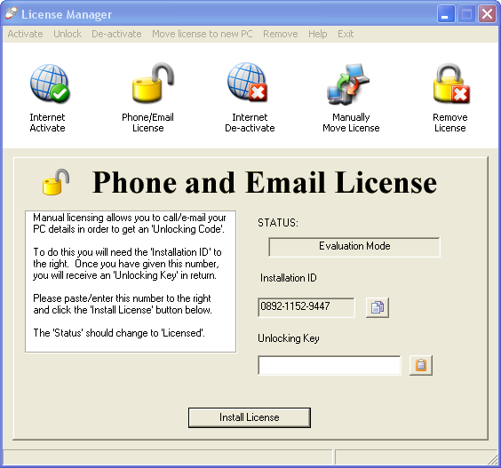

Once noted you must visit the Self Service part of the Nalpeiron Licensing Service and enter these numbers to get an unlocking code. Entering the unlocking code back into the License Manager installs the license on your PC.

This can be done any time you wish; you simply have to copy a numeric code.

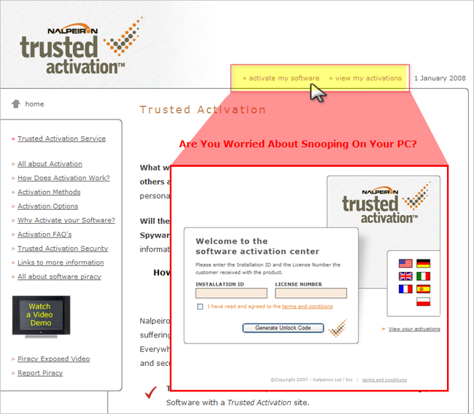

You can access this at any time from www.trustedactivation.com or control activation will open the browser at the correct URL.

Clicking on the “activate my software” link opens the self service portal from the www.trustedactivation.com site.

First, you choose your language of choice from the flags on the right of the page, the default is English.

Clicking on the flag (language) buttons opens the center in the relevant language.



As of 1/1/2008 there are 6 languages supported.
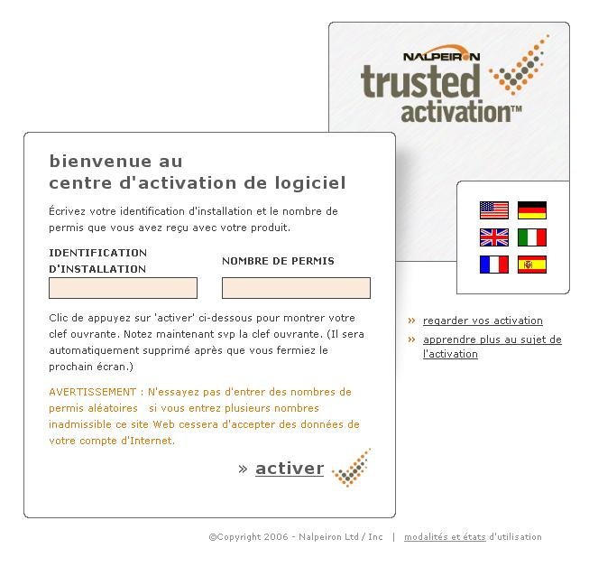
This is the French page for example.
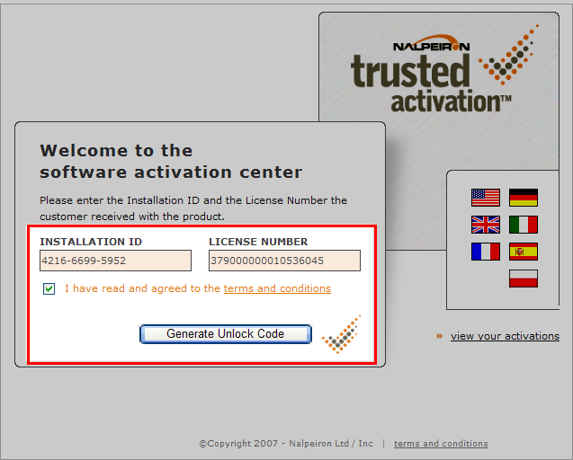
This is the License No./Code/Activation Code. You will provide this in your confirmation of order or on the CD/Literature shipped with your product, if you are using the optional activation service.
The InstallationID is provided by the you, as below, by running the control activation utility on their PC.

Enter these numbers to get an unlocking code. This can be done any time you wish; you simply have to note a numeric code.

Upon successful input of both the Installation ID and the License Number, you click the ‘generate unlock code’ button to access the final screen. (See below)

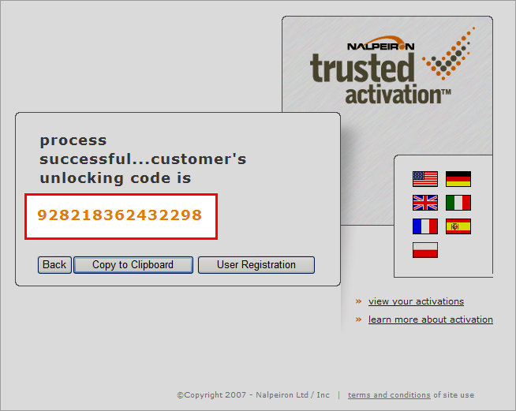

This is the final screen: This shows the Unlocking Key for input into the dialog box below:

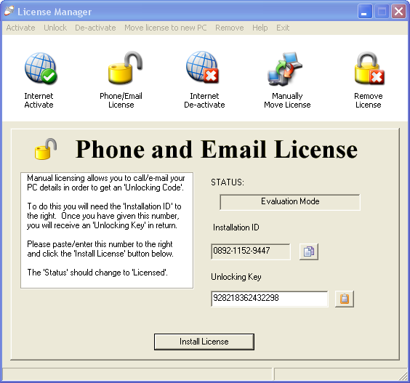

Enter the Unlocking Key in the Dialog Box and click “Install License”.

Upon successful entry of the unlocking key, you will be able to use your product.

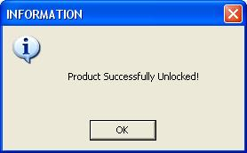

Please note the change of STATUS showing the product as Unlimited License - a useful reference point.

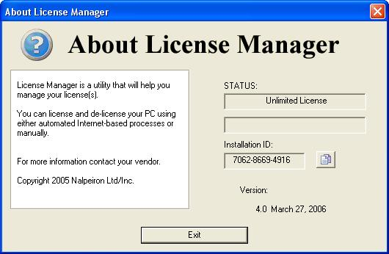

Obviously, our Activation Service will check the use of License No’s to prevent copying!

If you have exceeded the limit set in your EULA for this license no. you will be informed via a screen below.

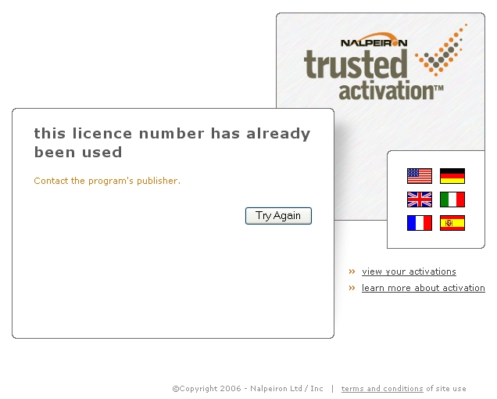

Manual Licensing using email/phone
In the Product Activation Window, choose the Unlock via telephone or e-mail radio button.

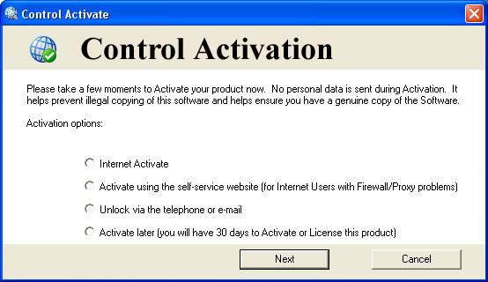

If you choose this option, it will launch the “License Manager” utility ready for you to quote us your “Installation ID” at the right hand side of the screen.

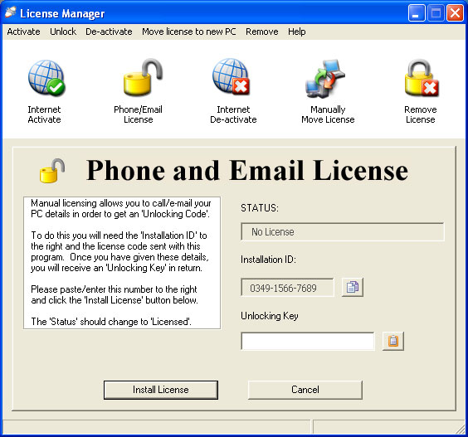

You can now call or email us with the following information:
- The License Number we sent with your order and;
- The Installation ID from the utility.

Using this information we can generate an unlocking key for you to put into the unlocking key dialog box underneath the “Installation ID” (as highlighted in green).

We will provide you with a simple 16 digit Unlocking Key; you just input this into the unlocking key dialog box and then click “Install License”.

  - If it’s via email, just copy and paste the digits into the Unlocking Key dialog box (See green box above) and click the Install License button.

  - If you are getting the number by phone, you may separate the Unlocking Key into 3 groups of 4 digits each, separated by either a space or a – or just enter in the number as one long string of digits. Then click the Install License button.

NOTE: You will be notified, if you enter an invalid Unlocking Key and the Installation ID will immediately change afterwards.

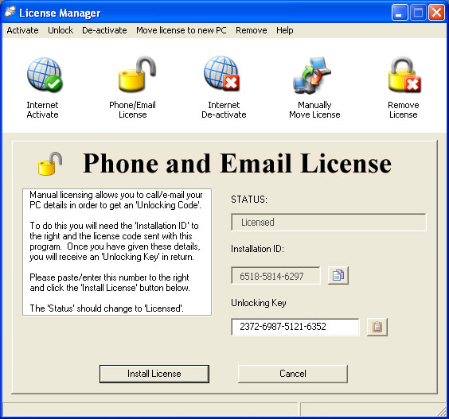

Please note the change of “STATUS” showing the product as Licensed - A useful reference point.

Move A License from Computer to Computer
If you are upgrading or wish to use the software on another PC you will need to move your license from the installed PC to a storage medium, the choices depending on your setup will be a USB Flash Drive or to the Internet. Then you install our Software application on the new PC and transfer the stored license to that PC. At that point the original PC will no longer be licensed.

All this takes a minute using the License Manager Utility.

You can move your license using a USB Flash Drive.

To manually move your license:
- Install our application on your new PC, this will also install the License Manager Program
- Run License Manager on your new computer.
- Insert the drive media in the applicable drive and note the drive letter.

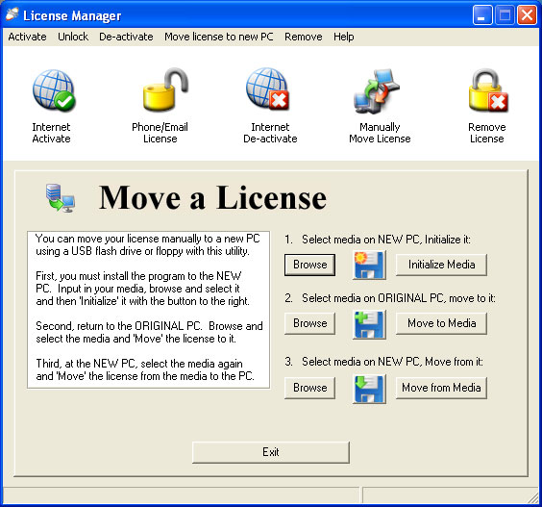

- Select the drive letter with your media in it by clicking the browse button.

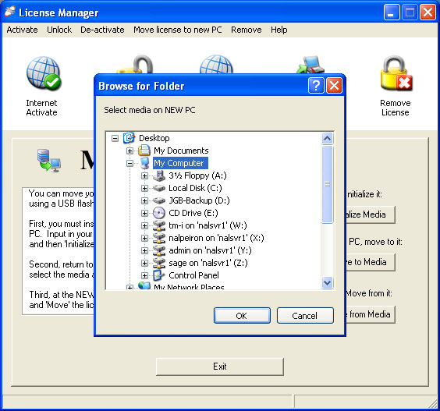

- The prompt box will display your PC drives. (as above)

- Click on Initialize Media for License Transfer to the media.

Then go back to the original PC:
  - Run License Manager on the computer which already contains the license.
  - Select the drive letter of your Initialized media by clicking the browse button.
  - Click on Move To Media button (as below)

Then go back to the new PC:
- Insert the media into the new computer and select the media drive by clicking the browse button.
- Click on the Move from Media button.

You are finished. The copy protected program now runs on your new computer.

Another way to move your License from PC to PC is to restore it to the Web Activation Server and then re-use it later.

Moving your license using the Internet (De-Activation)
To access this function you will need to run the “Internet De-Activate” Utility.

This function will allow you ‘store’ your license for future use or when you wish to move to another PC. You re-enter your License Number in the Dialog Box and click the “Return license” button. Once you have done this you can then re-use the same number in a new installation, following the Activation options above by clicking the “Activate Product” button. The PC which you have used this function on will now no longer be licensed.

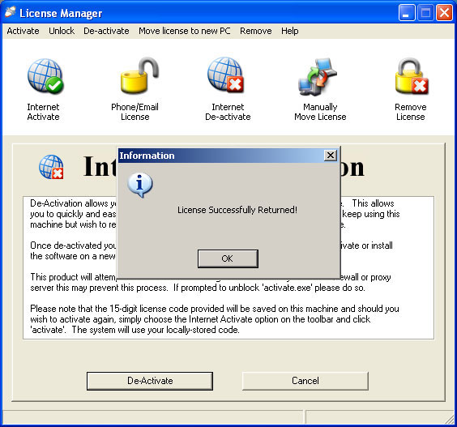

When you have returned a license successfully you get the above screen.

Your “license number” will be saved locally and will appear in the license number box should you wish to re-activate on this PC.

If you now wish to move your program to a new PC, just simply re-install our program and re-use the license number you have ‘returned’ to the server and go through the activation process again.

Remove a License with Proof that It was removed
To access this function you will need to run the “Remove License” Utility.

WARNING: THIS IS A PERMANENT PROCESS!

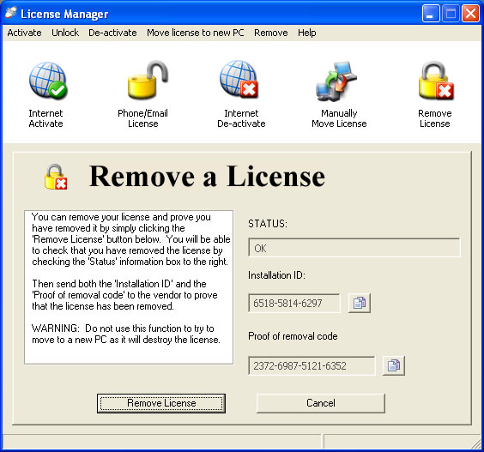
This the End User’s License Manager Utility.

- Run the License Manager
- Click on Remove License button
- When asked if you are sure, click Yes
- Contact your software publisher with the Installation ID (See red box above) that is displayed and the Proof of Removal Code (See green box above).
- The software publisher will confirm that your License has been successfully removed.

